# Data Quality Expectations

* Here, we will talk about **data quality expectations in Lake flow declarative pipelines**.You will understand what expectations are and how to define them in both SQL and Python syntax.
* **Expectations are equality constraints** that validate data as it flows through ETL pipelines.
* You can configure these constraints with the expect function, which specify the condition your data must meet.
* Any violation of your expectation will be tracked and reported in metrics.
* **By default, records violating constraints will be kept in the table**. However, you can add the violation clause to define a different action, either to remove the records that violate the constraints or to cause the pipeline to fail when a violation is detected.

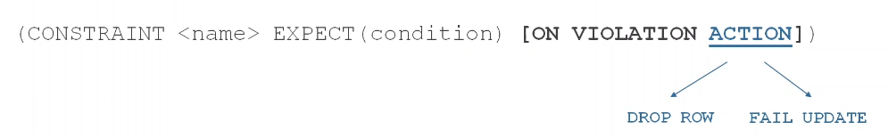

* Pipeline expectations are also supported in Python using the functions **expect**, **expect_or_drop**, and **expect_or_fail**.

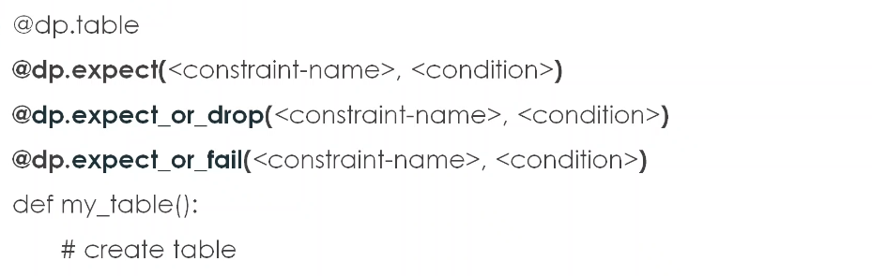

* Here is an example to apply three different expectations on a table in both SQL and Python syntax. And of course you can add as many expectations as needed.

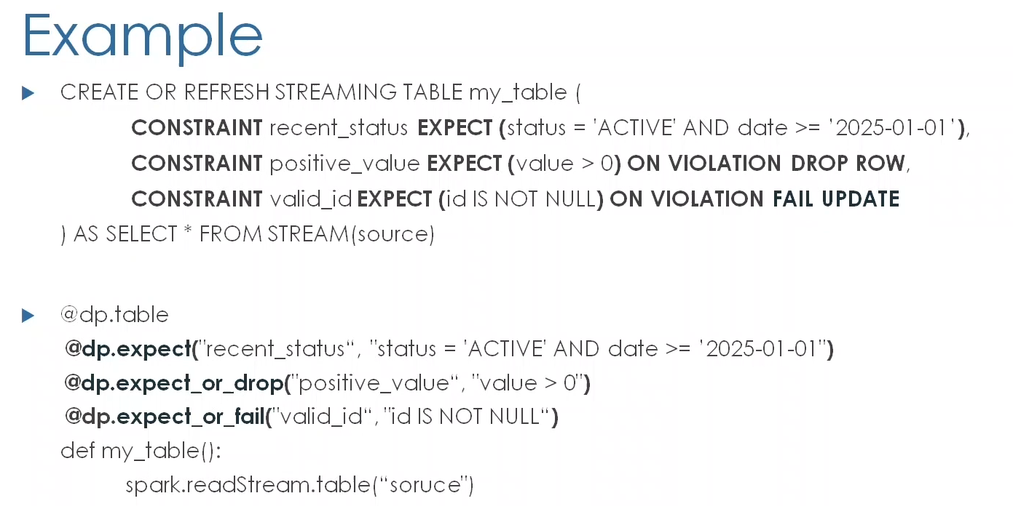

* Moreover, in Python, you can group multiple expectations in a dictionary and specify collective actions using the functions **expect all**, **expect_all_or_drop** and **expect_all_or_fail**.

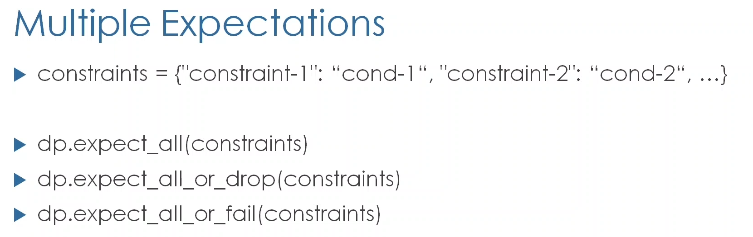

* Here we see a summary of the actions, their SQL syntax, and the corresponding function in Python syntax.

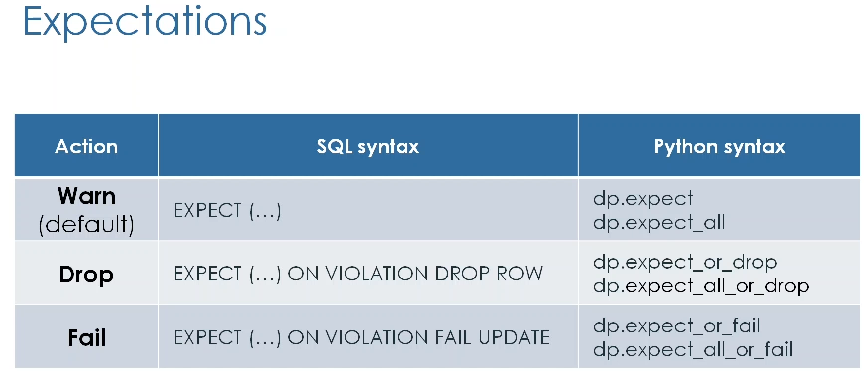

* **Again, by default it's just a warning**, so invalid records are written to the target table, but their account is logged in metrics.
* With the **drop action** invalid records are dropped before data is written to the target table, and their count is also logged in Metrics.
* Lastly, with the **Fail action**, invalid records cause the corresponding flow to fail and roll back the updated transaction. In this case, manual intervention is needed to fix the issue before reprocessing.

# Data Quality Expectations (Hands On)

* Here, we will continue building our **bookstore pipeline** using lake flow declarative (i.e. LDP) pipelines. We are going to implement data quality expectations while processing our **books** and **orders** in the silver layer.

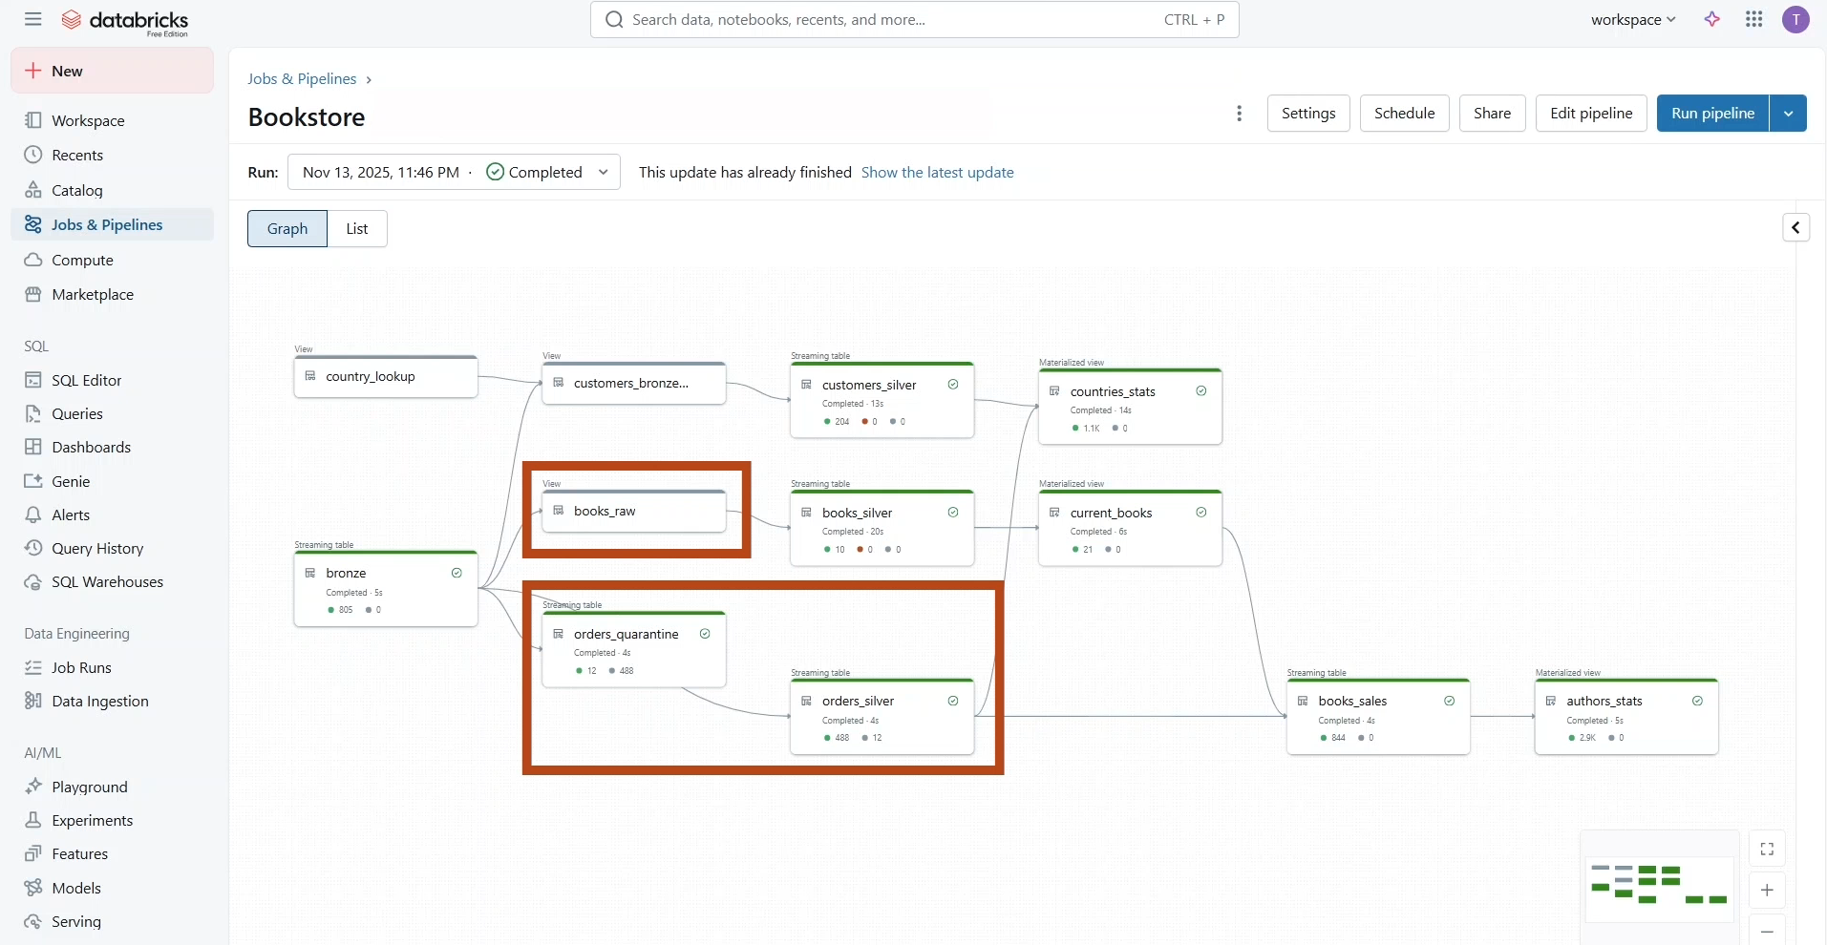

* To start, navigate to **Job and Pipelines** in the left side bar and click on **Bookstore Pro** pipeline that we created Last Lecture.

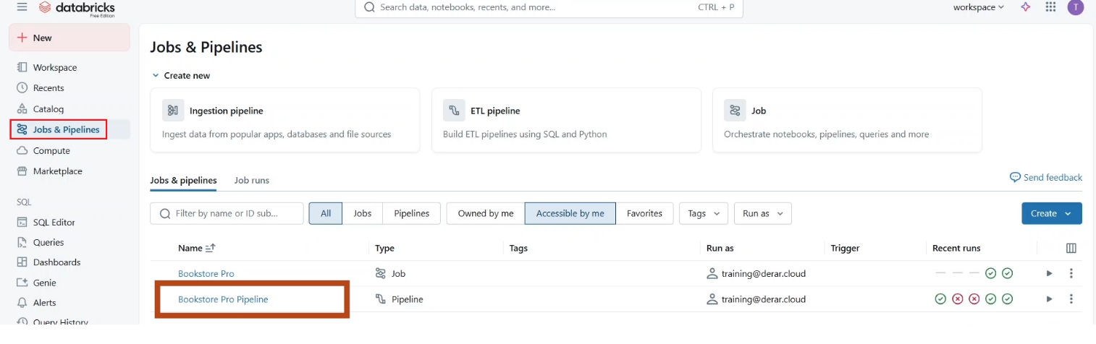

* This interface shows the **pipeline monitoring page**. To modify the pipeline, click **Edit Pipeline**.

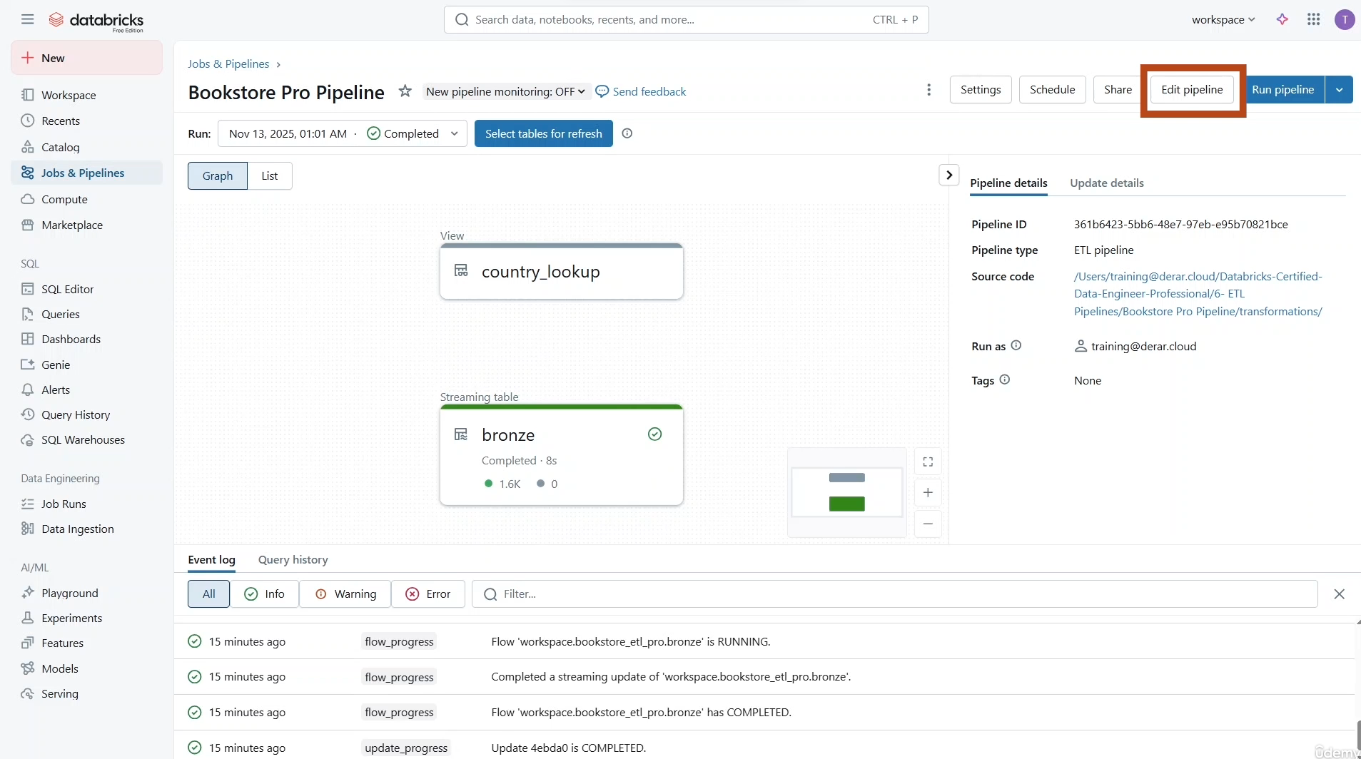

* Remember, you can go to the **pipeline monitoring page** by clicking on the **run results**.

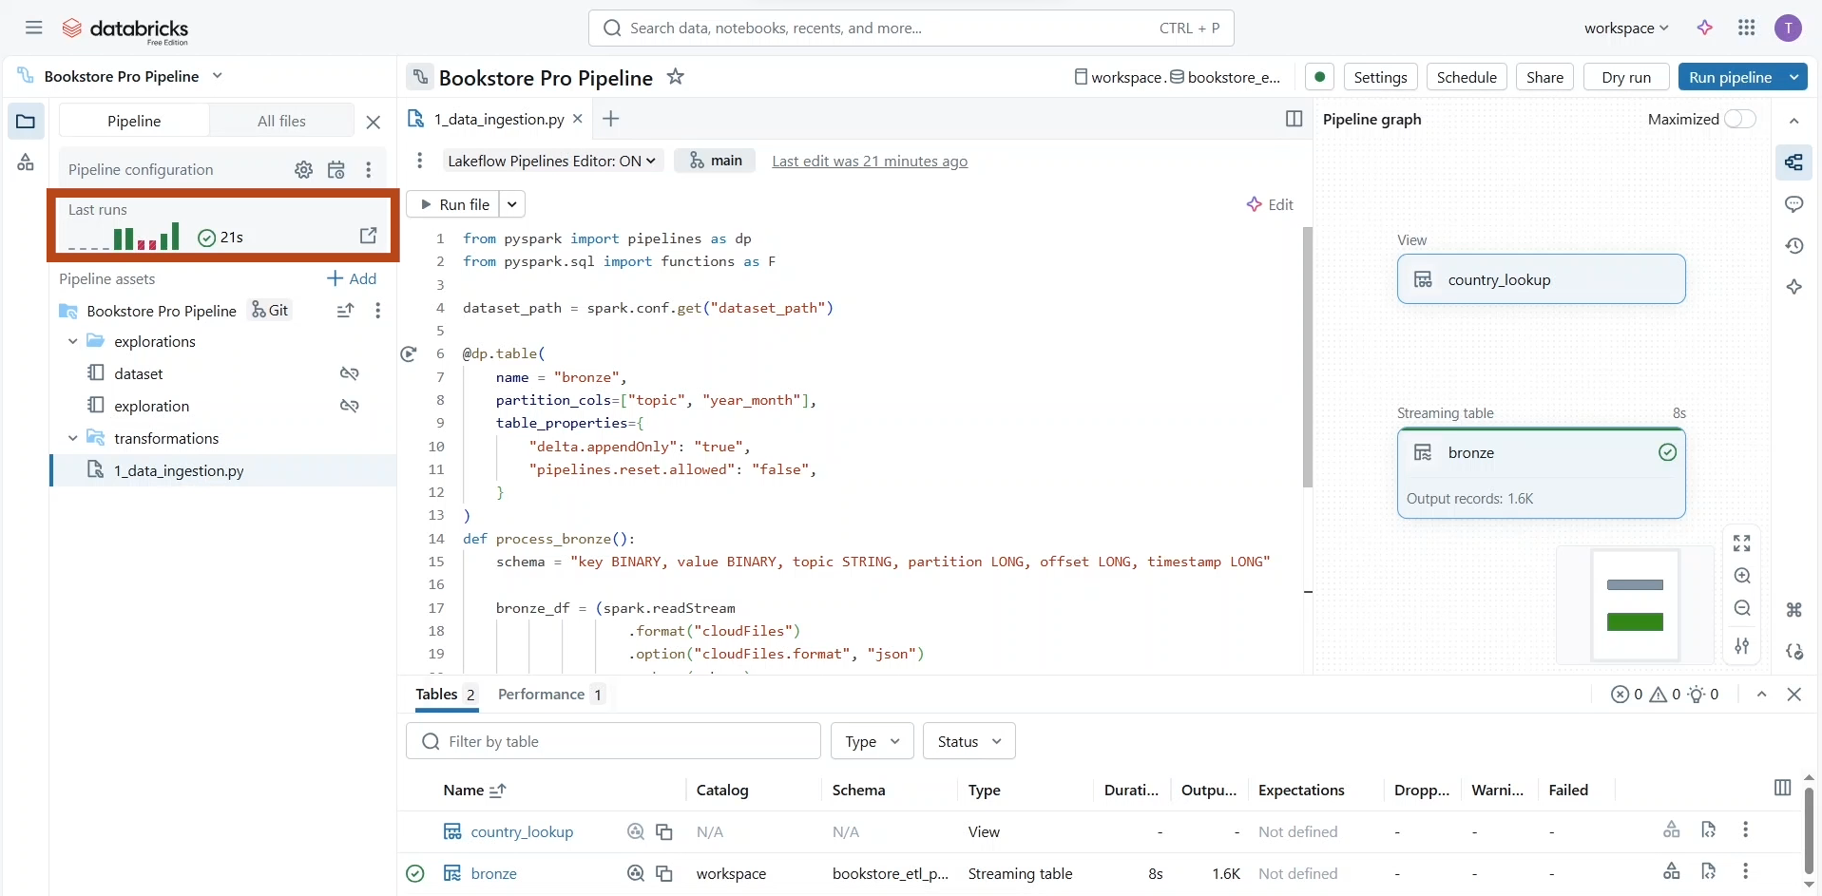

* Let us add another **Python source file** to define our **silver table** with data expectations.

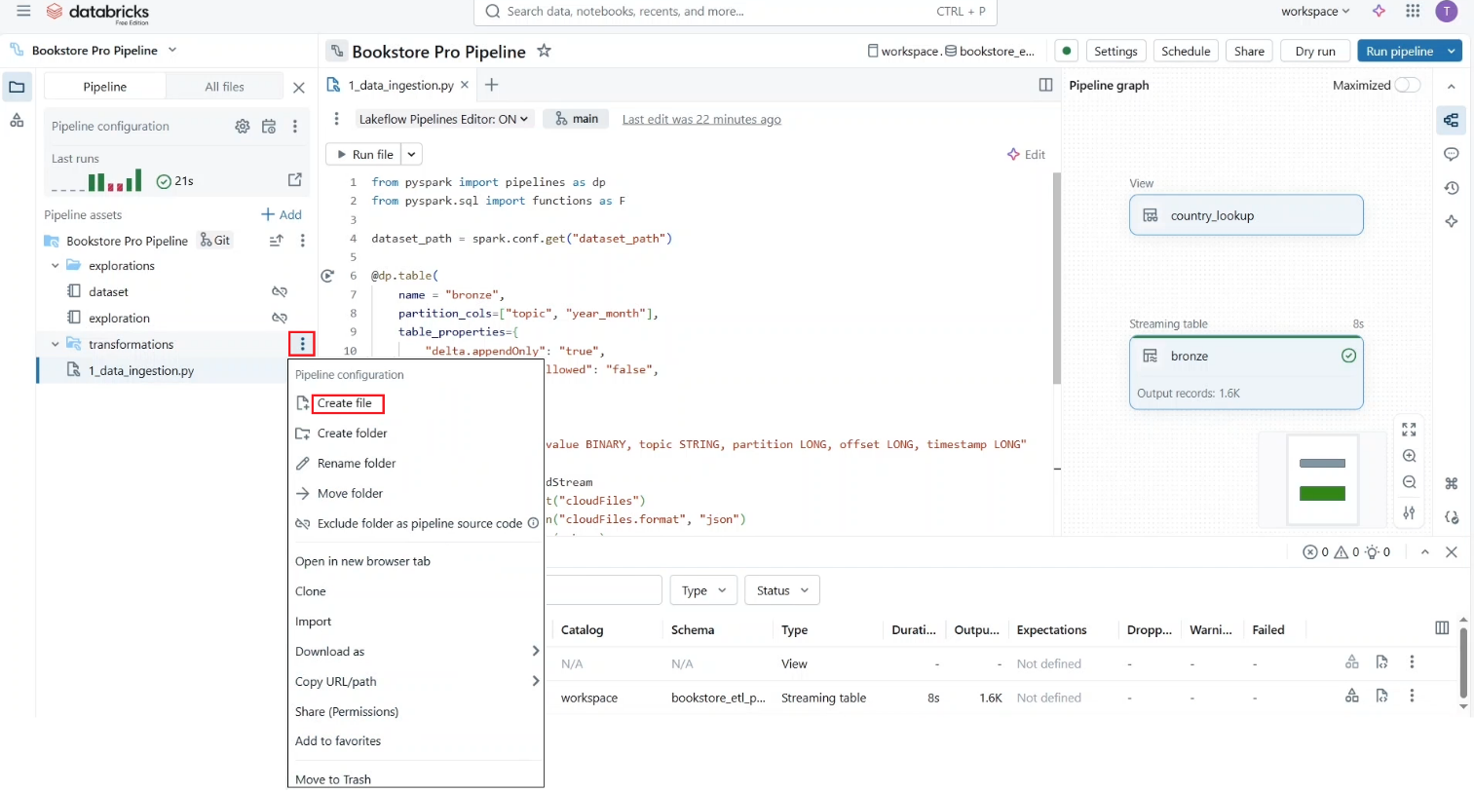

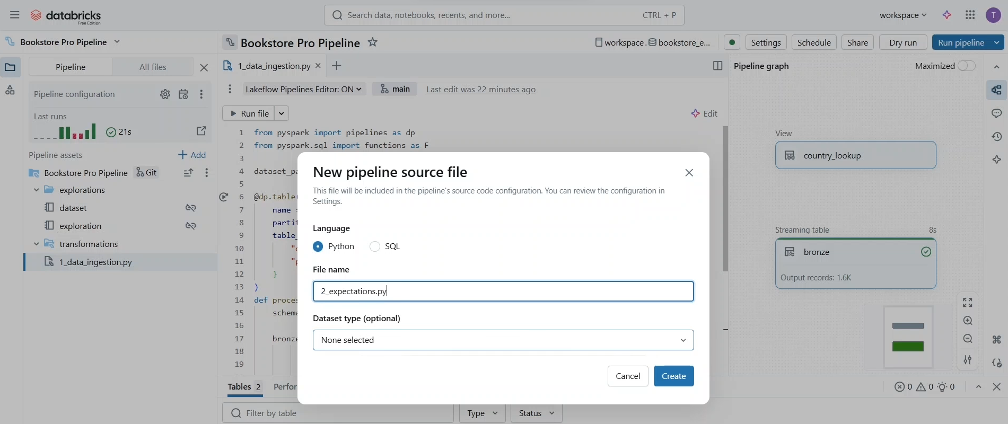

* As usual, we start by importing the pipeline and functions modules in a source file. You can not only define tables but also functions for custom processing. Let’s create a function called “**process_orders**” to process the **order topics** from our **multiplex bronze** table. Notice here that we are creating the **bronze** table that we created in another file in the last lecture. This is possible because they are all parts of the same pipeline. This bronze table **persisted to the default Catalog** and **schema**. If it were created in a different Catalog or schema, we would reference it using a three-level namespace instead.

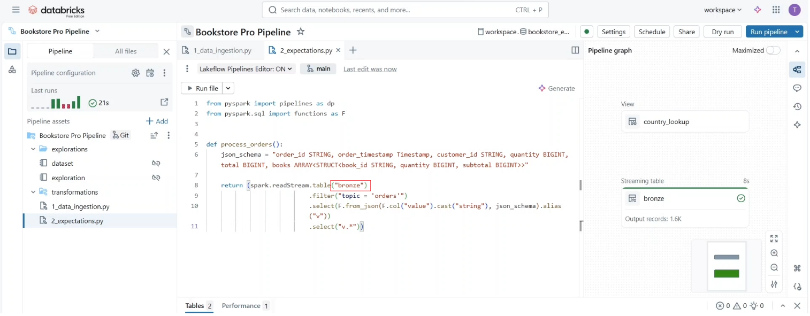

* Next, we will define a **streaming** table **orders_silver** by simply calling the “**process_orders**” function and returning the resulting streaming DataFrame. This means we are creating the **orders_silver** as a streaming table.

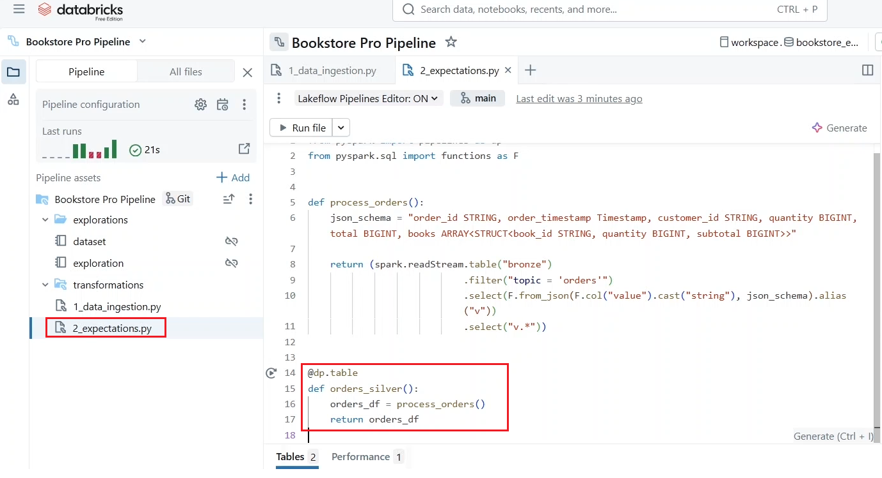

* Next add the silver layer then we apply data quality control. We can achieve this here in our pipeline using data expectations. Let us add one called **valid_quantity** to ensure that the ordered quantity is greater than zero.
* Here we are using the **expect decorator**, which means we will just collect metrics about constraint violations while violating records will be written to the orders table.

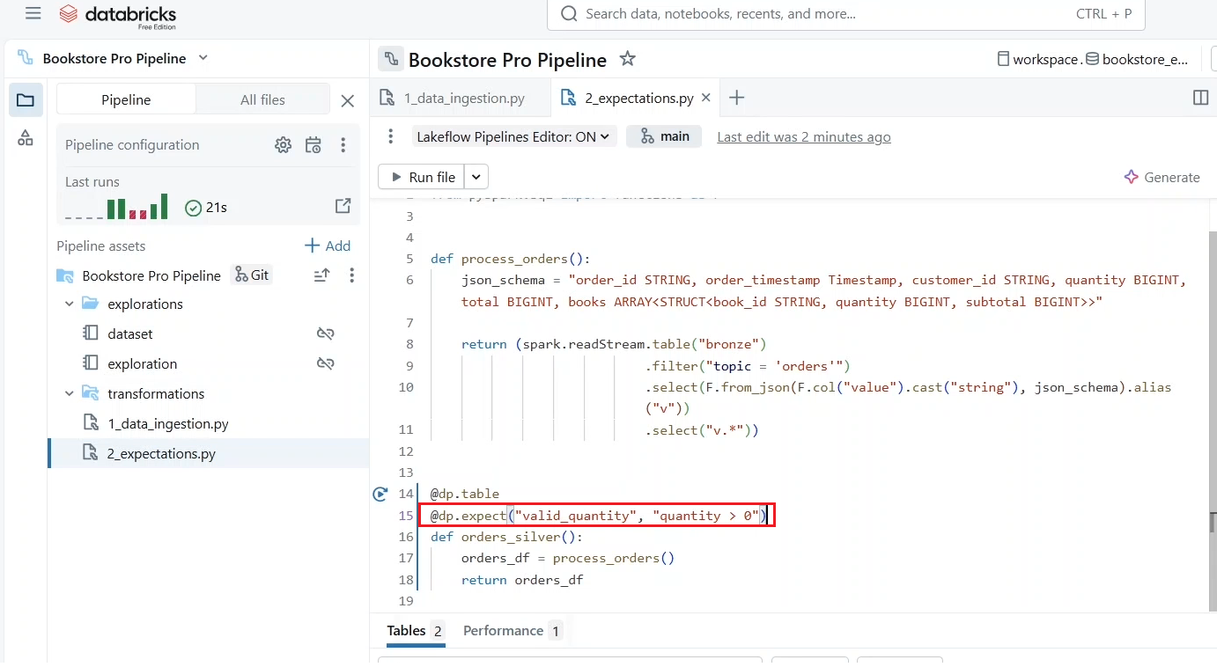

* Let us run the pipeline via clicking on “**Run Pipeline**” to confirm this. Let us maximize the pipeline graph by clicking here.

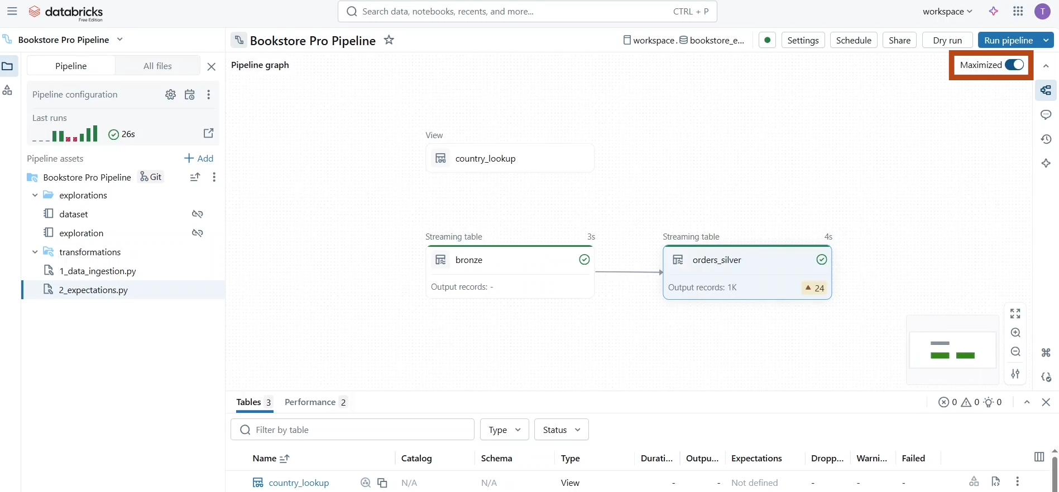

* If we click on the **orders** table. Under the **data** tab, we can see that all 1000 records have been written to the table.

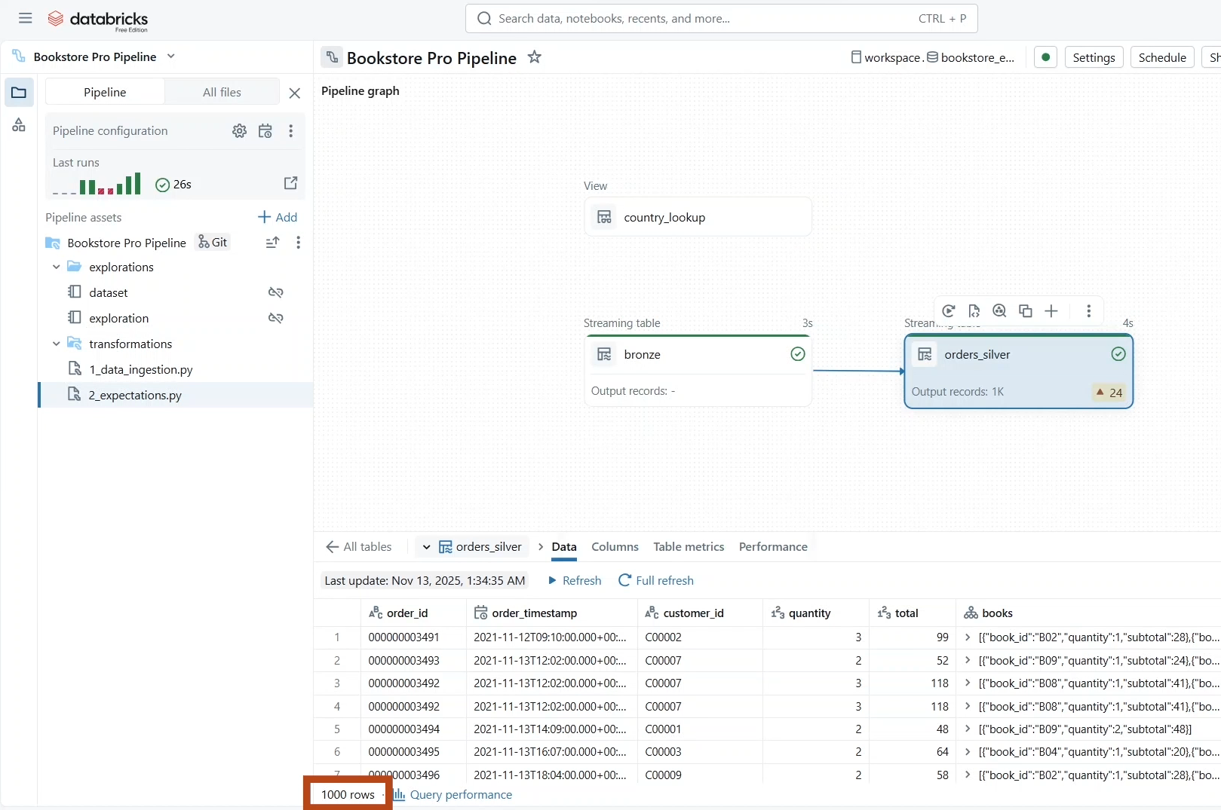

* But under the **Table Metrics** tab, we can see that there is an unmet expectation with 24 warnings.

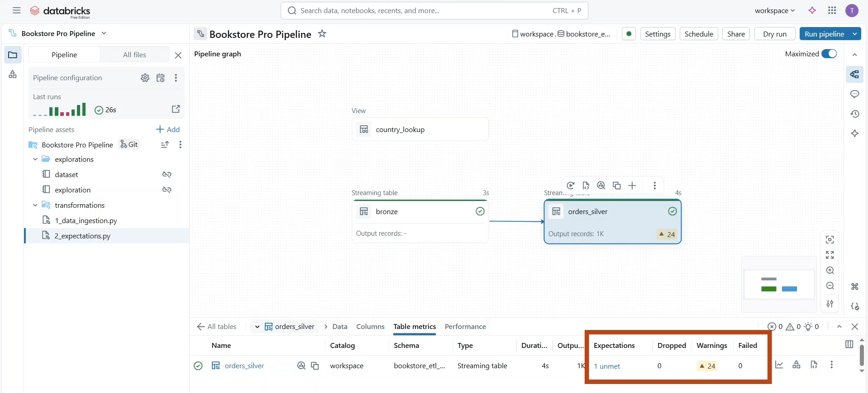

* If we click here, we can see that 24 records didn't meet our valid quantity expectation. However, this is just a warning. While those records have been allowed to be written to the table, this is because we use the **expect** function.

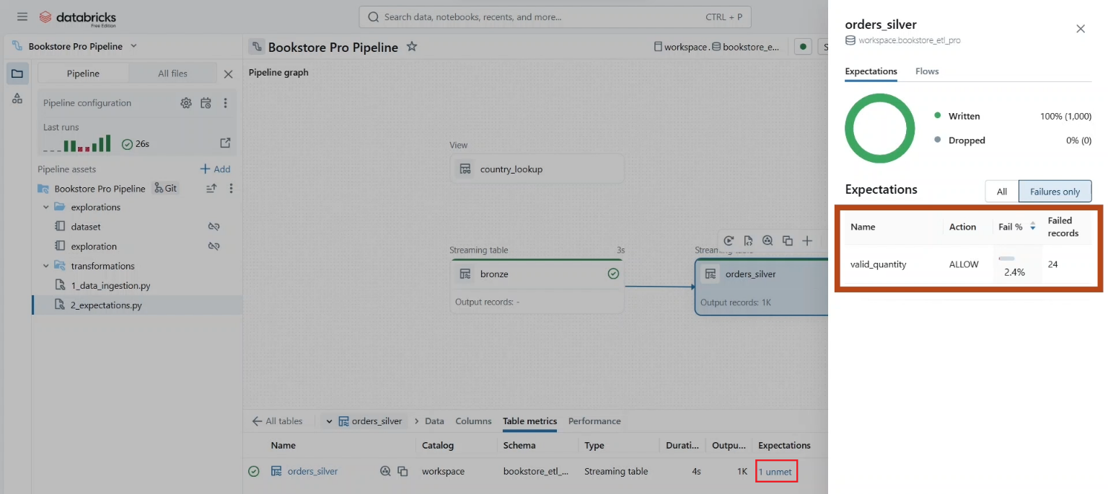

* If you prefer to have a **behaviour** similar to **Delta Lake check constraints**. You can use the **expect_or_fail** decorator, which stops the processing when such records encountered.
* Let us **run the pipeline with full table refresh**, this time to process those table again.

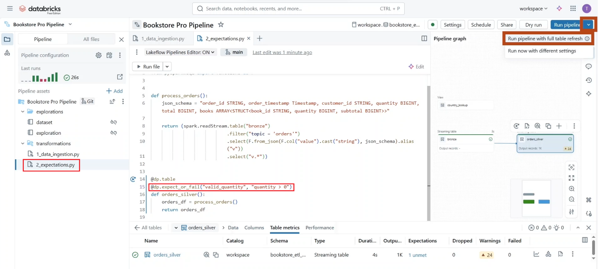

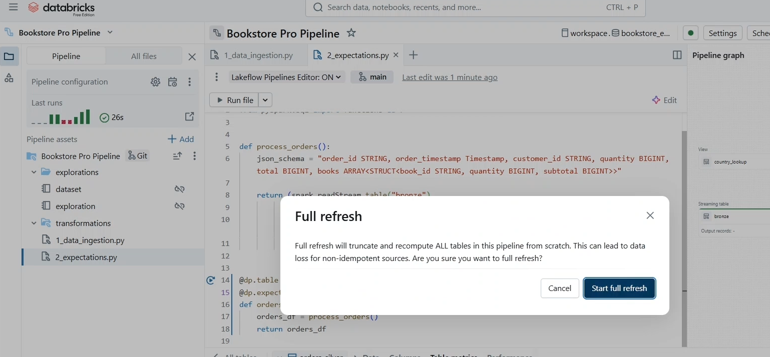

* Remember, this run will not affect our **bronze** table because it was defined with the table property “**pipelines.reset.allowed**” set to “false”. As expected, the pipeline stopped execution because the data failed to meet to our defined expectation.

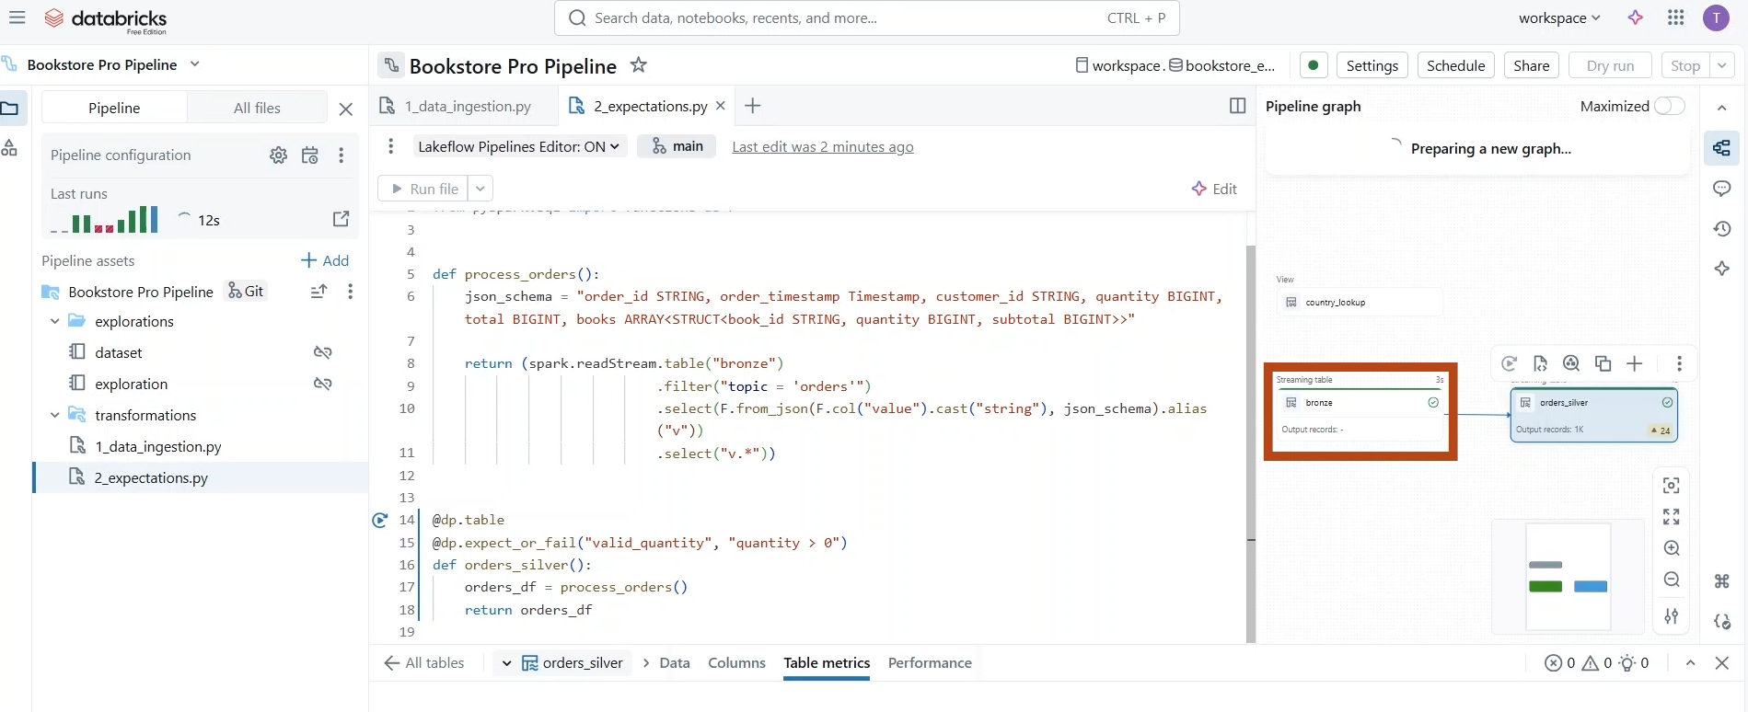

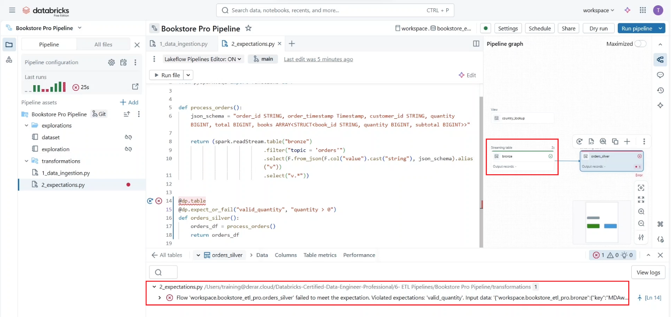

|  |
| --- |
|  |

* If you prefer to keep your pipeline running while **dropping any violating records**, you can use the “**expect_or_drop**” **decorator**. Let’s run our pipeline again with full table refresh.
* Now we can see less records written to the table, and under the table metrics, we can see that the 24 records have been dropped from the table because they didn't meet our valid quantity expectation.

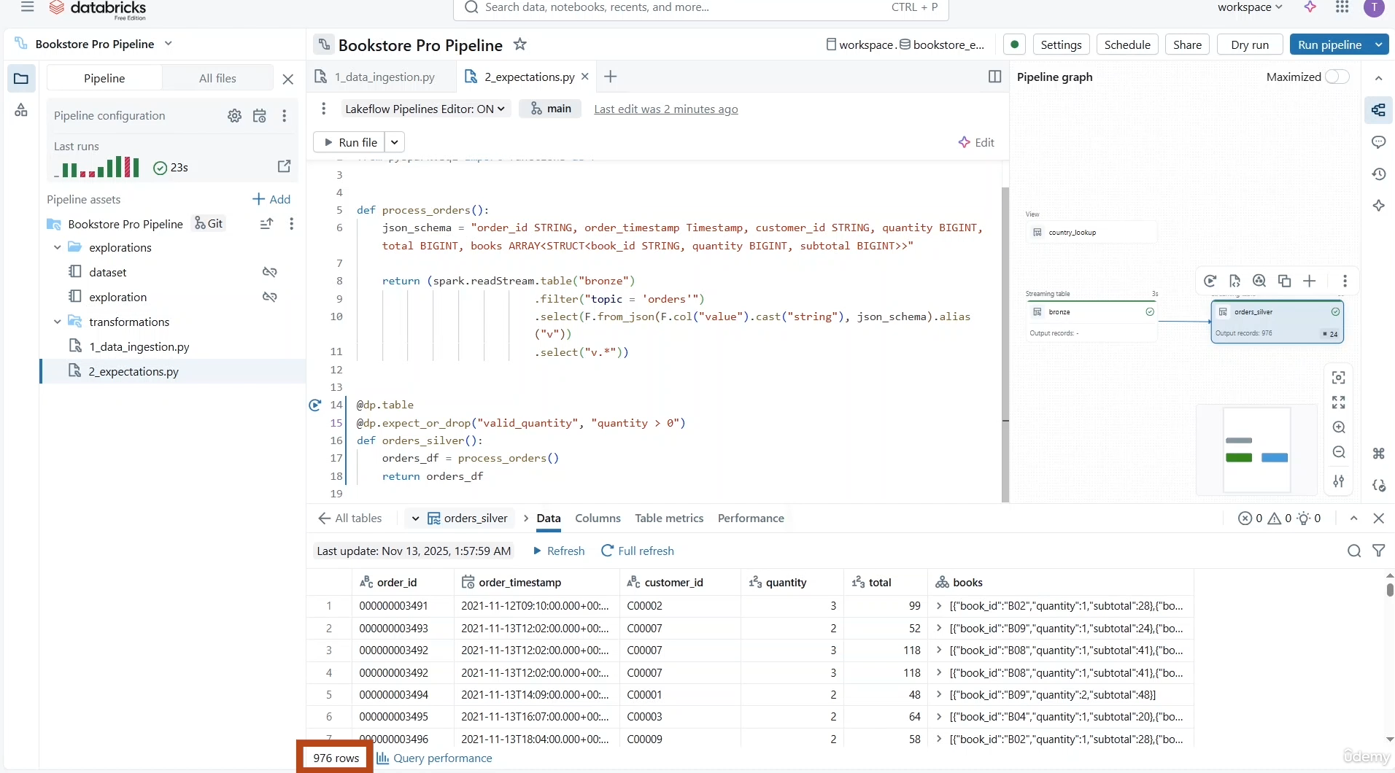

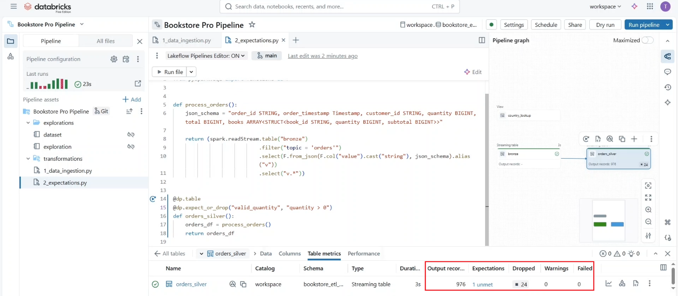

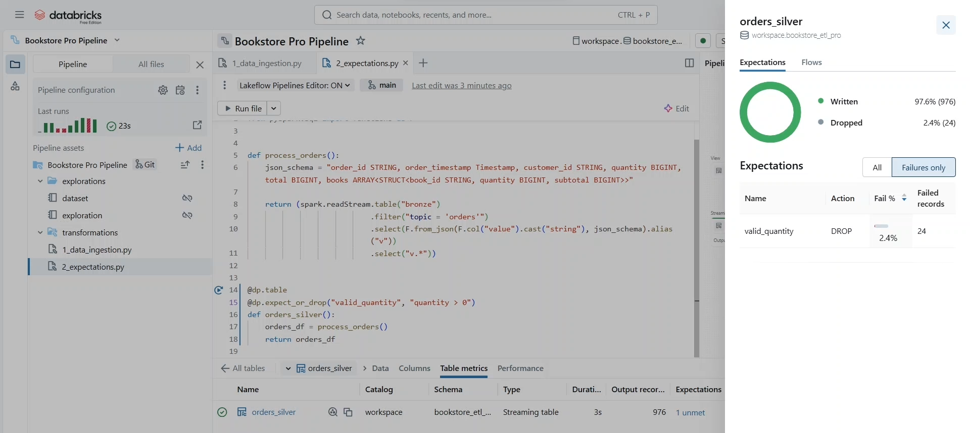

* Now, what if we still want to keep the **invalid records separately for a future review**? For this, we can isolate them in a **quarantine table**. On this table we simply apply the “**expected _or_drop**” function on the negation of our rule. In other words, quantity less than or equal zero.
* So, this will **drop the valid records** while **writing the invalid ones in the quarantine table**.
* Let us run the pipeline again to confirm this.

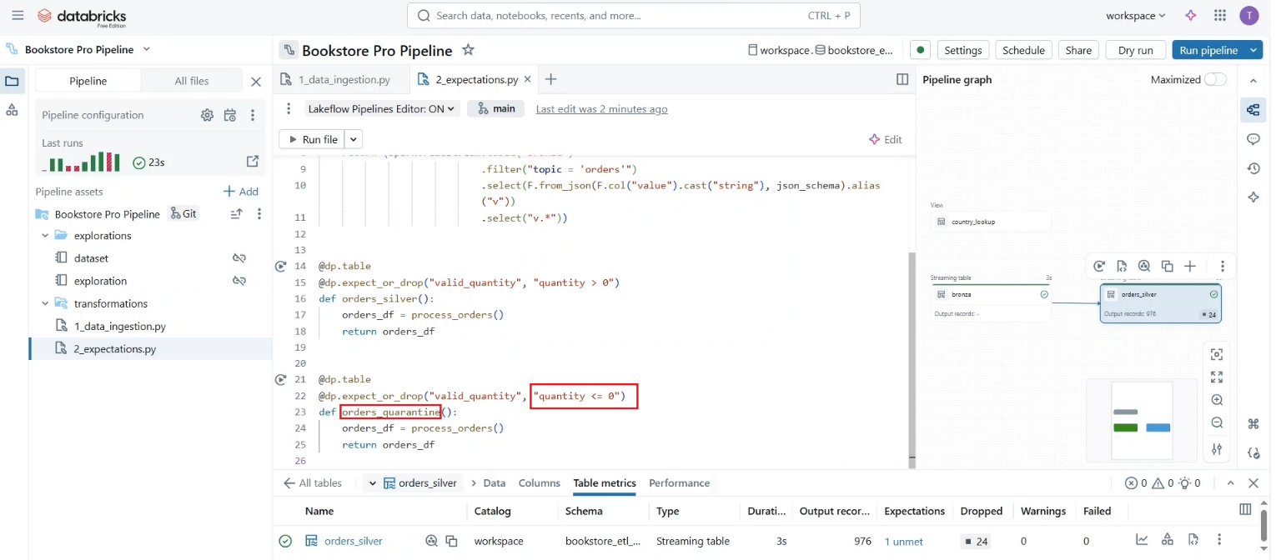

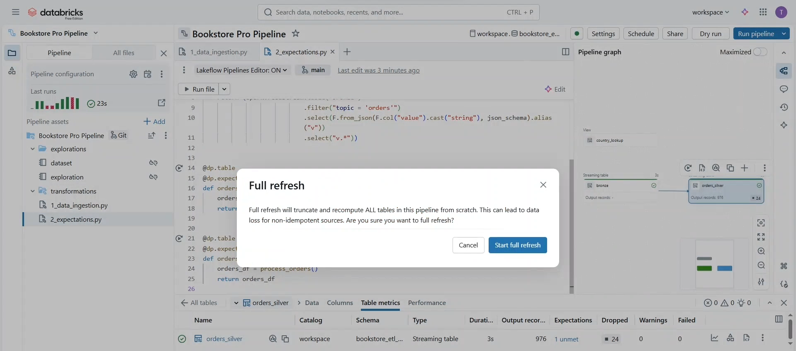

* As you can see now, we have two tables. The **orders_silver** table with **976 valid** records and the **orders_quarantine** table with those 24 invalid records.

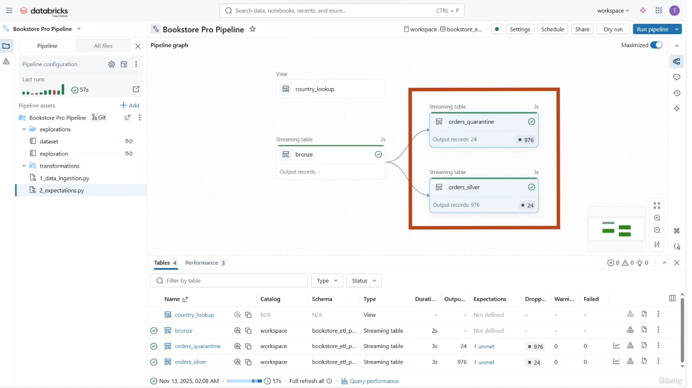

* We can also apply data quality on temporary views. Here we are creating a temporary view “**books_raw**” for processing the books topics from our multiplex bronze table.
* You can add as many expectations as needed. For example, let us add the three warning expectations on the updated date, price, and book ID. 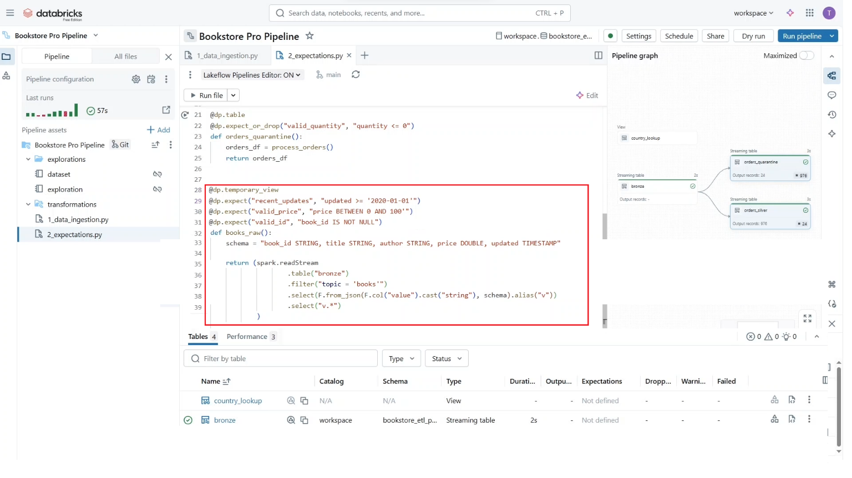
* Let us test this. Notice that **data preview** is not available for **temporary views**.

Below Graph view is possible via clicking on “**Maximized**” option only.

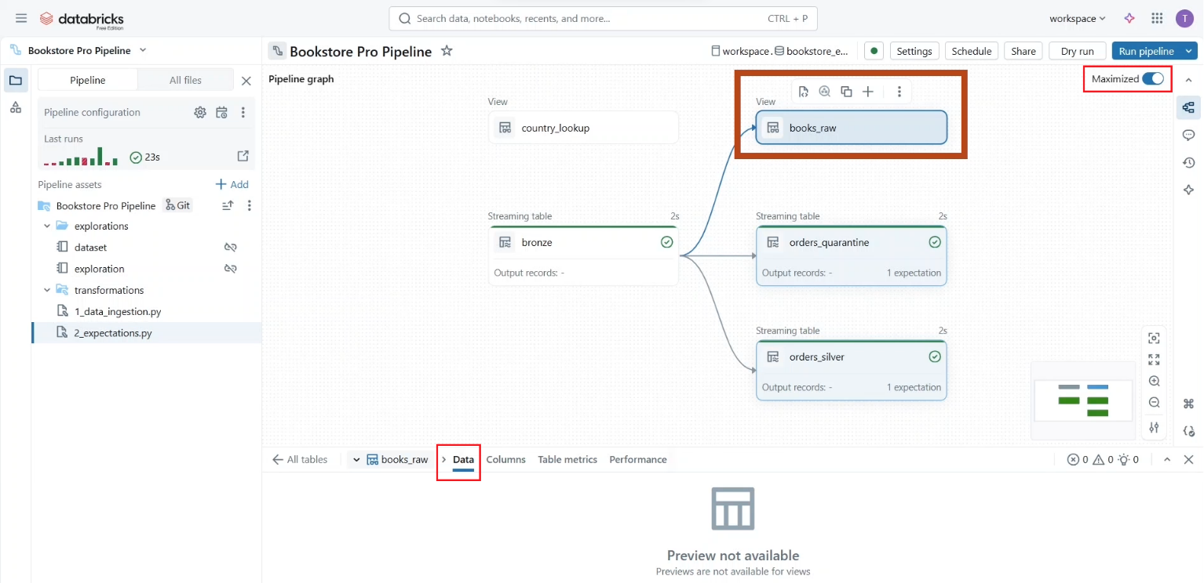

* But we can still check the table metrics to see that our **three expectations** have been correctly defined.

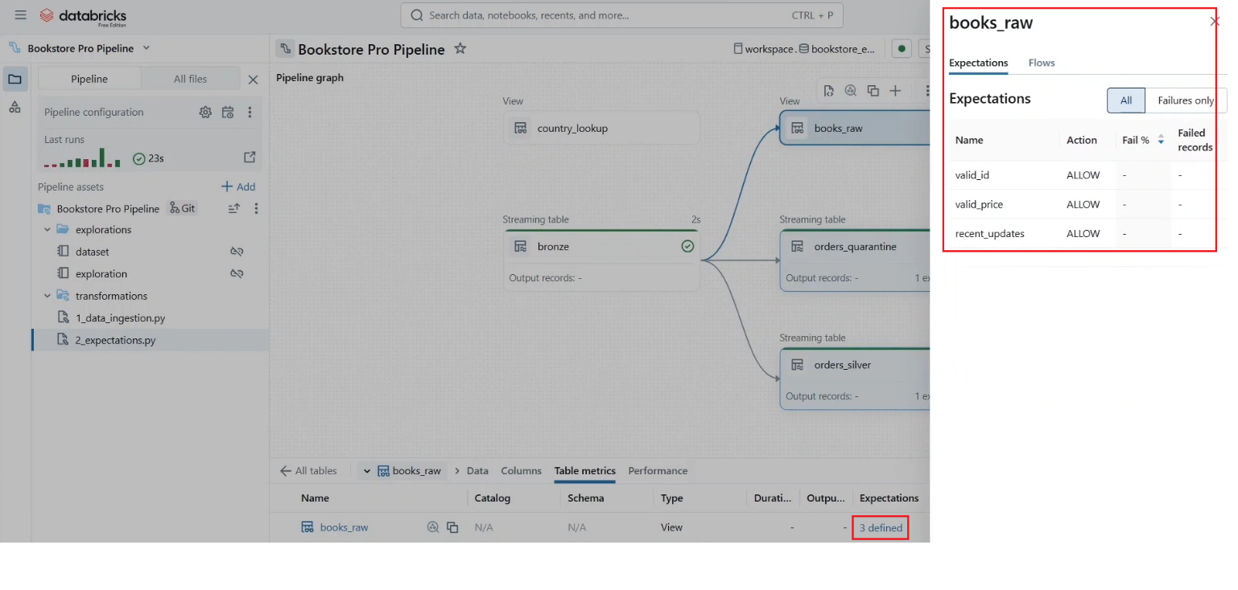

* Instead of listing these expectations like this, we can group them in a Python dictionary.
* And now, instead of the **expect** function, we can use the **expect_all** function on this dictionary. Of course, you can use other functions like **expect_all_or_drop** and **expect_all_or fail**, depending on your business needs.

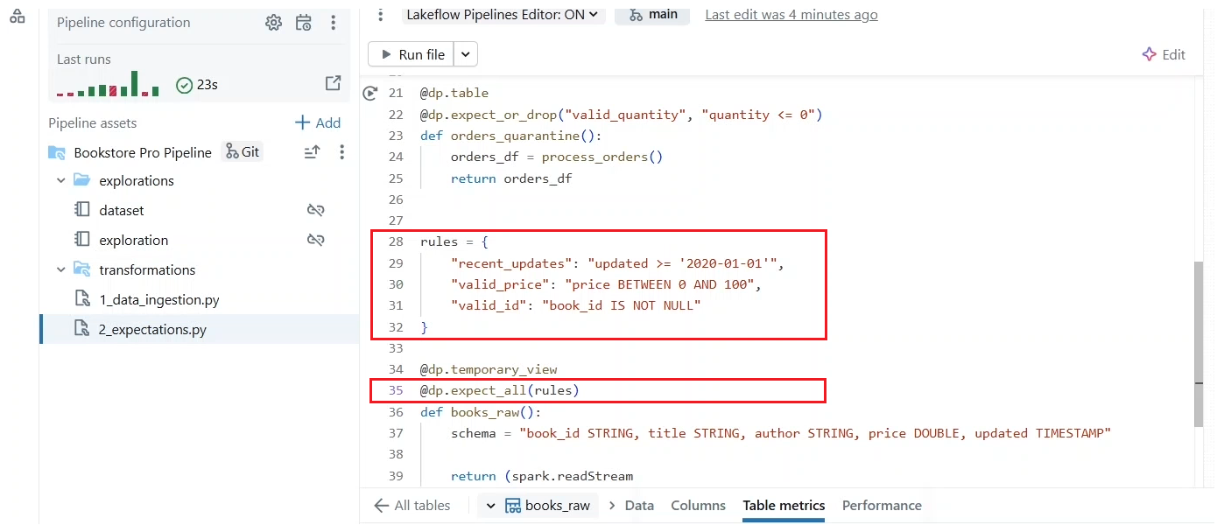

* Now what if we still want to **identify the invalid records**, but **without creating a separate quarantine table**? A common pattern in this case is to add a Boolean flag in the table to identify those invalid records. Here we add the column is quarantined and we can define. It is Boolean expression to be the negation of our validation rules combined together. With this pattern, you can also partition your table on this column to physically separate the invalid data in the underlying table directory.

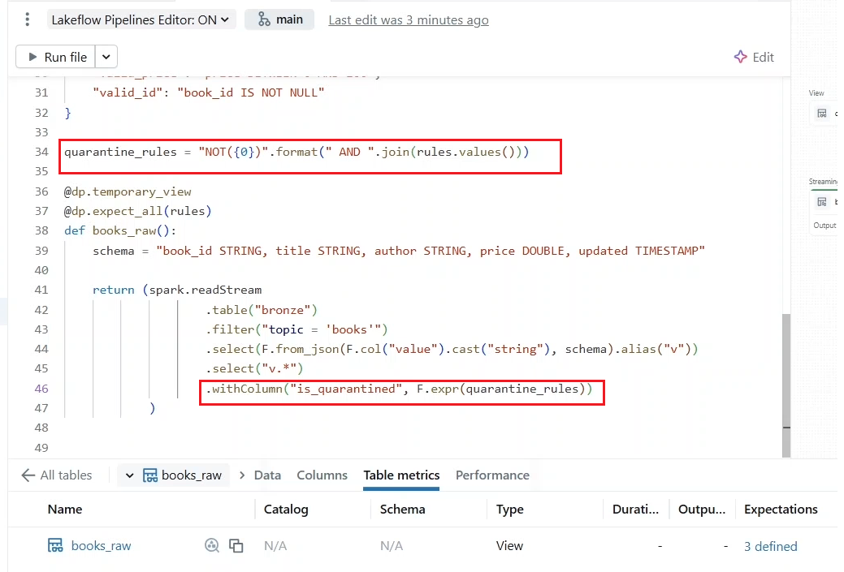

* Let us run the pipeline. So again, the **data preview** is NOT available for temporary views. Reviews, but we are going to use this review in the next lecture and learn how to persist these results. But from the **table metrics**, we can confirm that the **expect_all** decorator has correctly defined our three expectations.

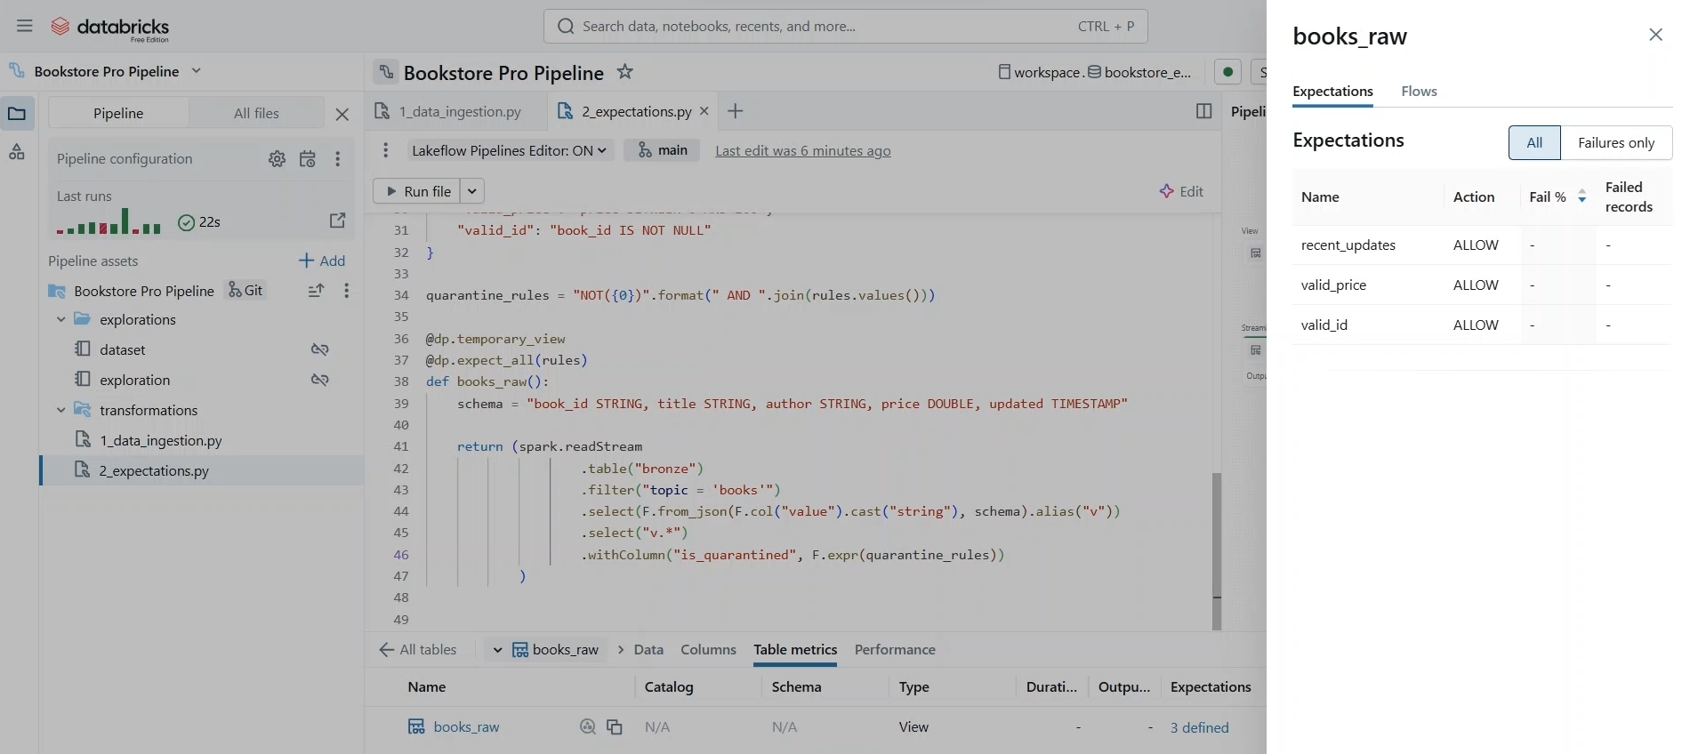

* And under the **columns tab** we can confirm the addition of the is quarantined column. So, the pipeline interface here is a great way to explore expectation metrics.

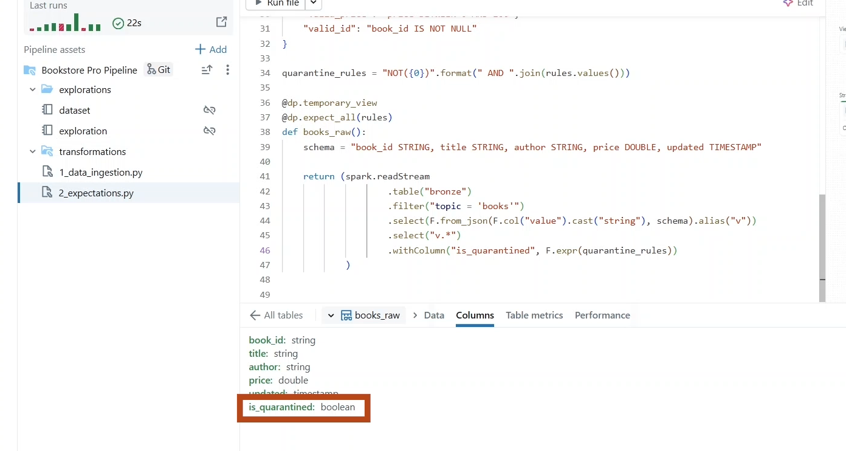

* But what if you need to programmatically access this information? To achieve this, we can leverage the **event log table**. Remember we configure the event log table of this pipeline in the settings menu during the last lecture.

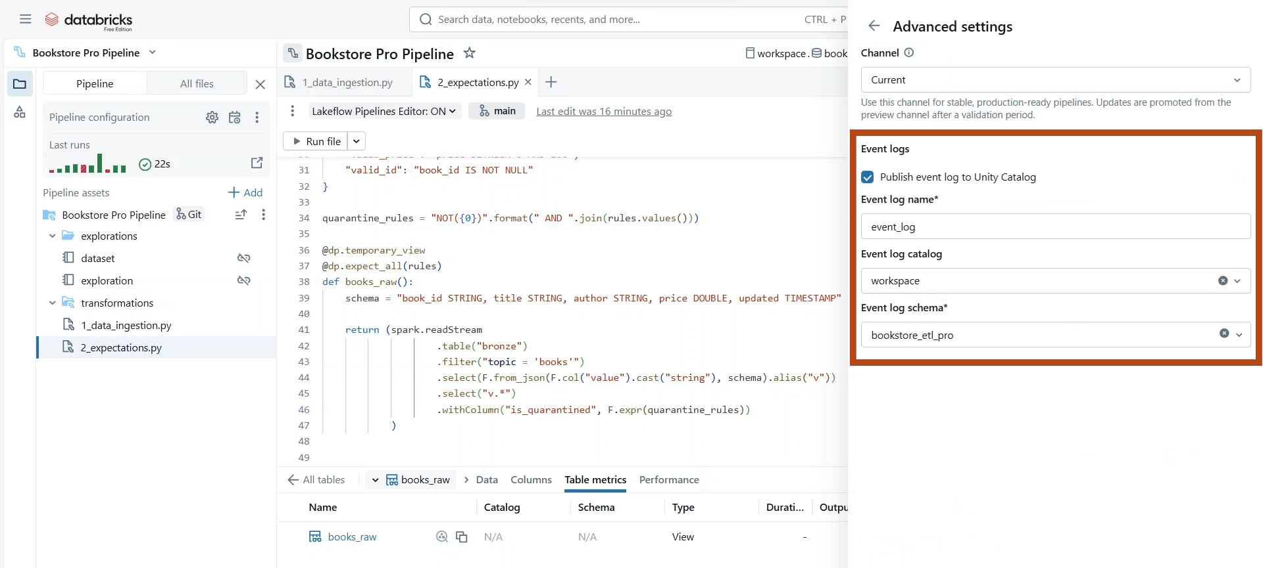

* Let us switch to the **SQL editor** to query this table. As you can see, all the events that we see in the pipeline Editor interface are stored in this table.

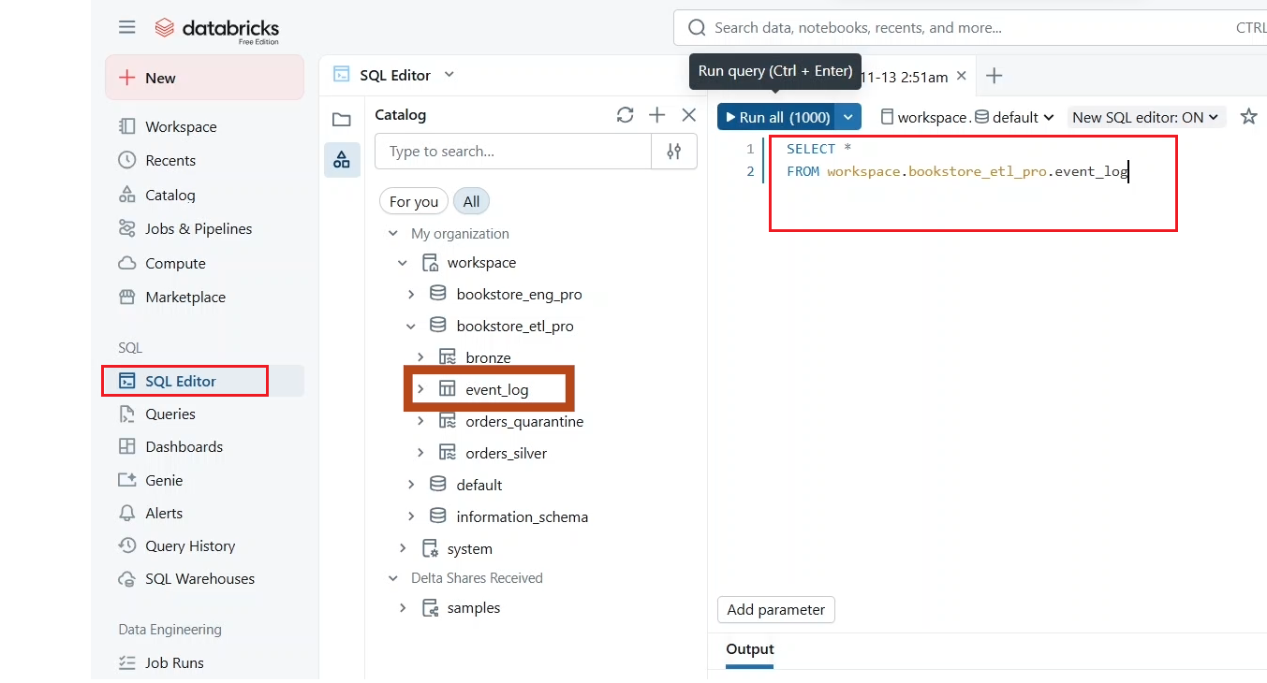

* The **data quality expectations** are stored under events of type **flow_progress** in the **details** **JSON column**. So, we can easily access them by traversing this nested object -> details:flow_progress:data_quality:expectations where event type equals flow_progress.

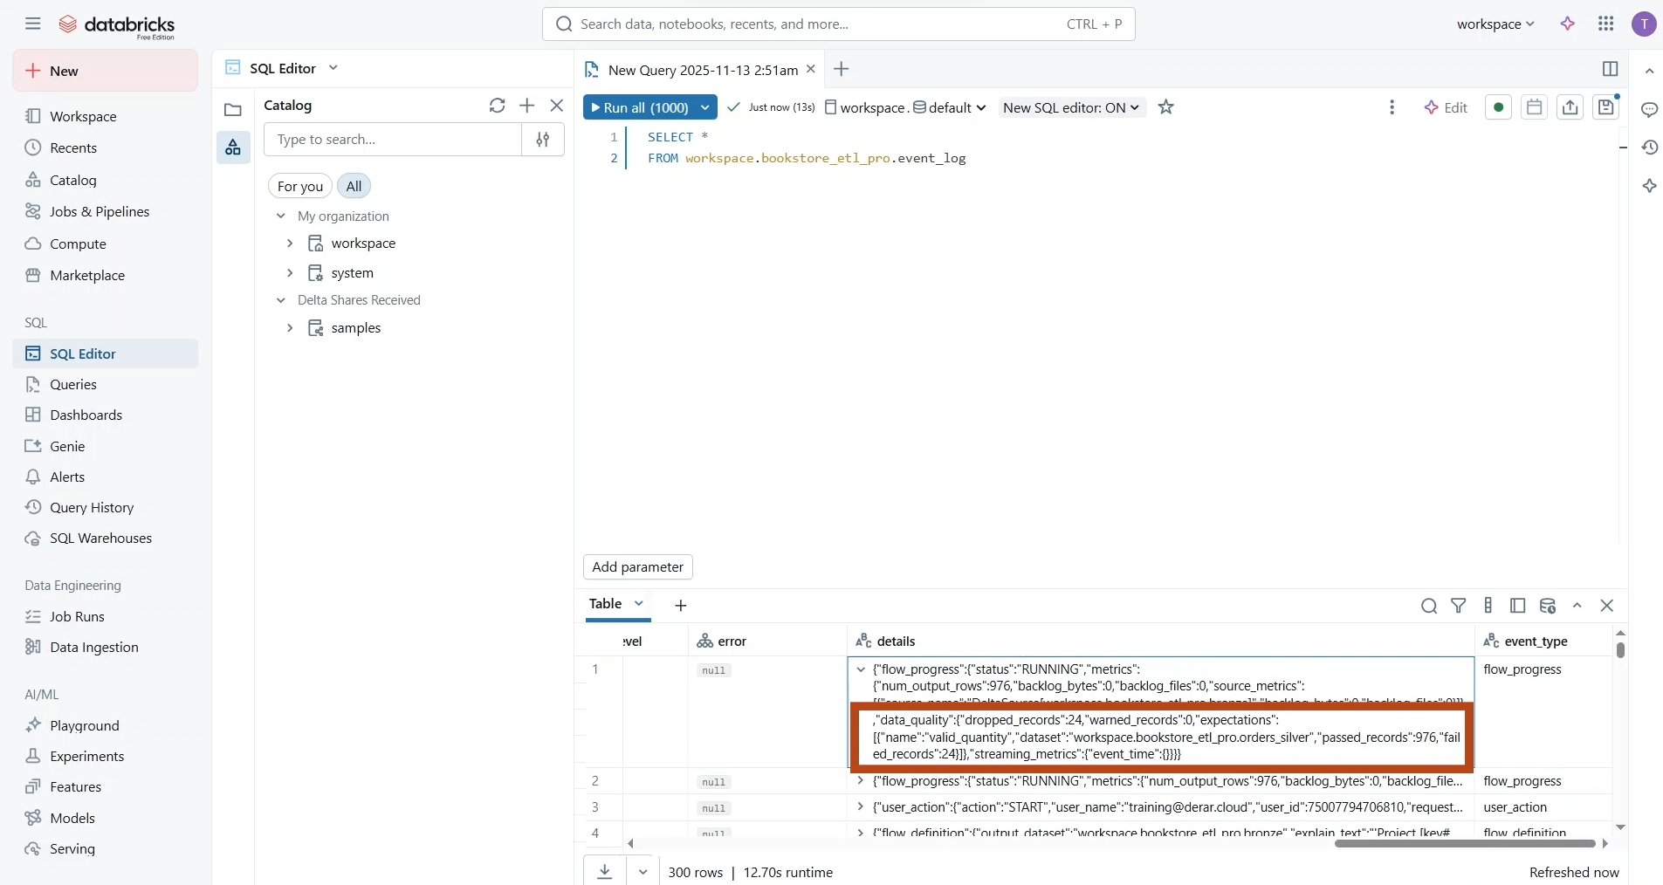

* Let us run this query.

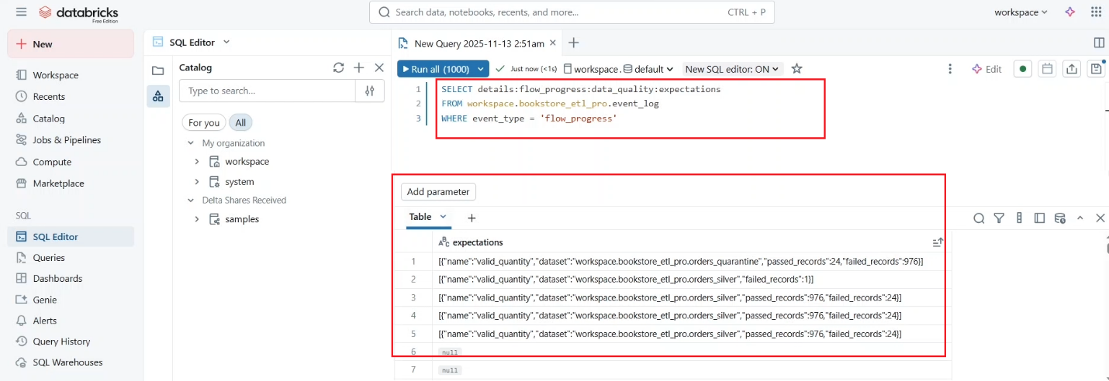

* As you can see, we managed to programmatically extract information like the name of each expectation, associated datasets, count of records that passed or failed the expectation.